NAME :RIYA SHARMA K ROLL NO :240701433
Data Visualization for an Inventory Management System

Aim
To develop a web-based dashboard that visualizes inventory data using graphical representations (Pie Chart and Bar Chart) to facilitate better stock management and analysis.

Procedure
The project was implemented using a combination of web technologies and an external data visualization library:

HTML Structure:
  - Defined two <canvas> elements with unique IDs (pieChart and barChart) to serve as containers for the graphics.
  - Imported the Chart.js library via a CDN link to enable advanced charting capabilities.

Data Modeling (JavaScript):
  - Created a central data object (inventoryData) containing labels for
various categories: Electronics, Clothing, Home Appliances, Books, and Toys.
  - Assigned specific numerical values to these categories to represent "Items in Stock."

Graphic Rendering:
  - Used the getContext('2d') method to target the HTML canvases.
  - Instantiated two new Chart objects:
    - Pie Chart: Configured to show the proportional distribution of inventory.
    - Bar Chart: Configured to show a direct numerical comparison across categories with the Y-axis starting at zero.
- Styling: * Applied CSS to center-align the content and provide adequate spacing for a clean, professional dashboard appearance.

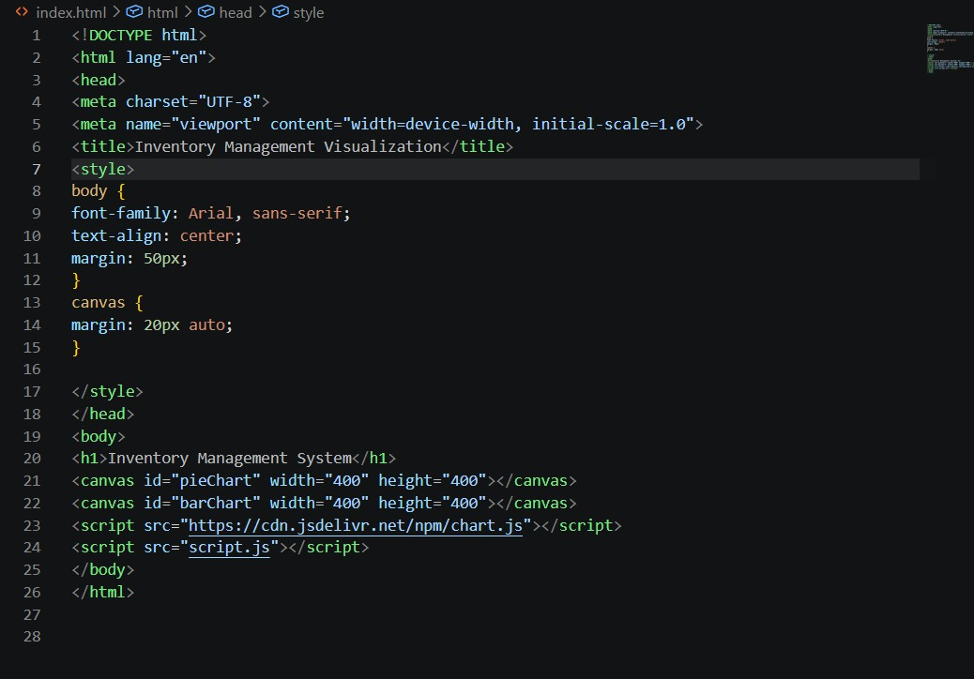

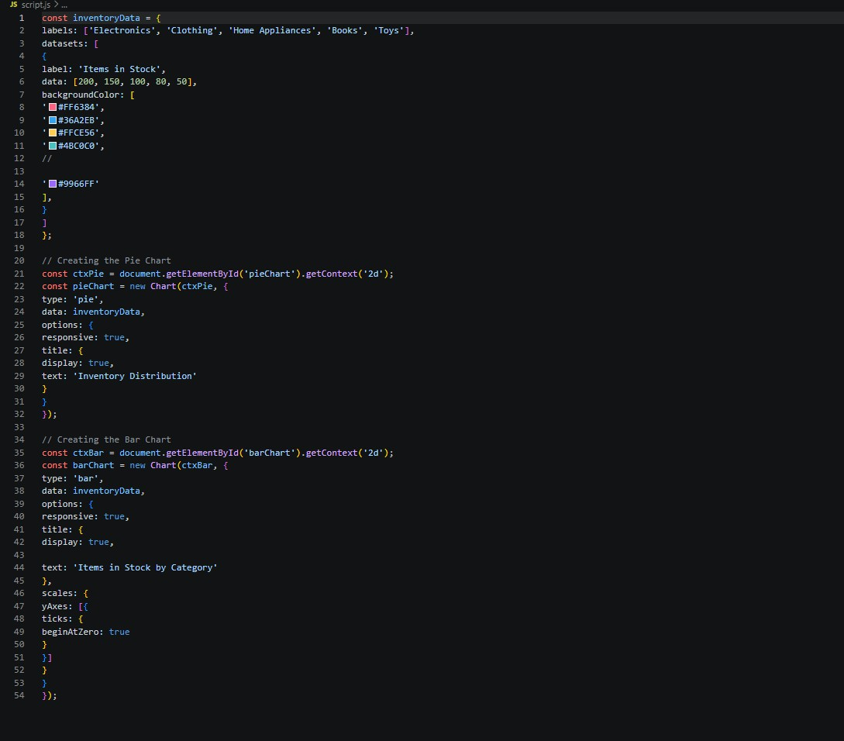
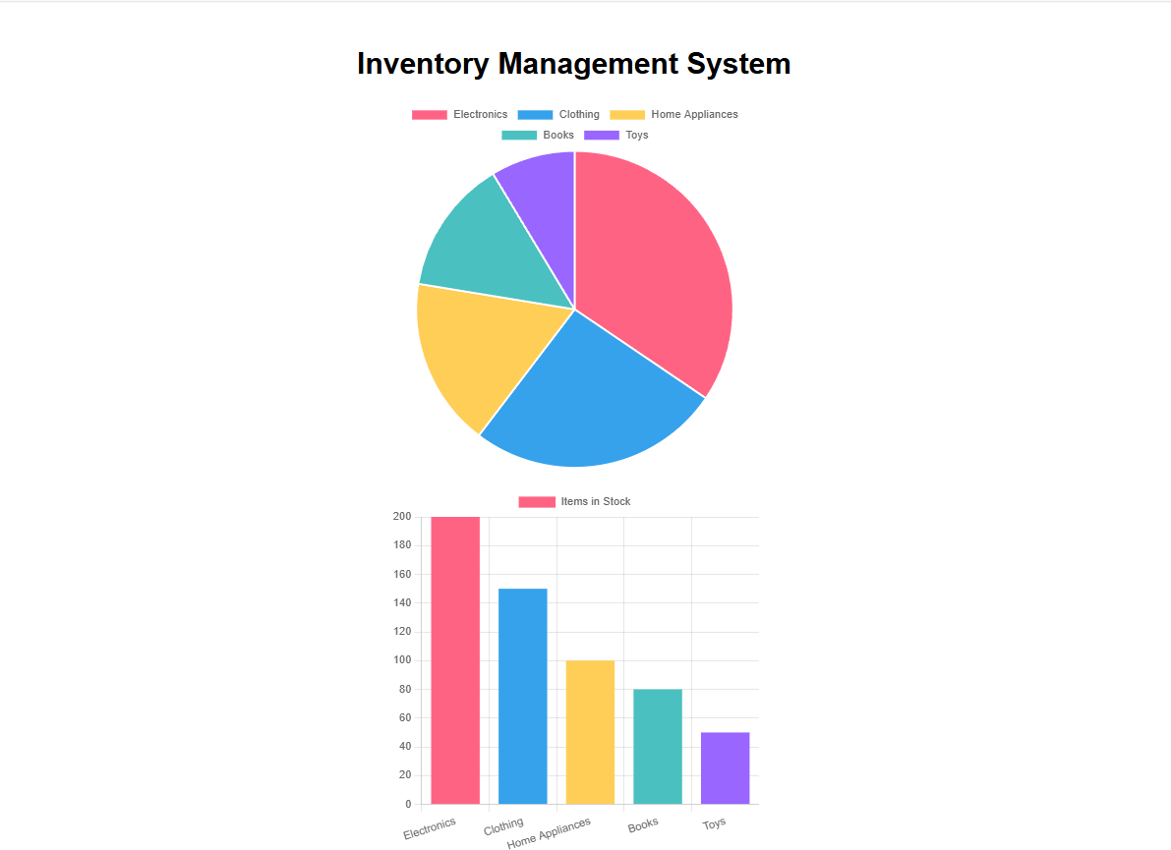

Results
The application successfully transformed raw numerical data into interactive visual components:
- Proportional Analysis: The Pie Chart clearly displays that "Electronics" occupies the largest segment of the inventory.
- Comparative Analysis: The Bar Chart provides an easy-to-read comparison, showing a downward trend in stock levels from Electronics (200 units) to Toys (50 units).
- User Interface: The final output (as seen in the screenshot) presents a
responsive and color-coded "Inventory Management System" dashboard that is easy for a user to interpret at a glance.

